WHOIS

🌐 What Is WHOIS?
# Source: Chatgpt (GPT‑5 Mini) at [12/15/2025]
WHOIS is a public internet lookup service used to find ownership, registration, and contact information for domain names, IP addresses, and Autonomous System Numbers (ASNs). It tells you who owns what on the internet.

🧠 Simple Definition:
# Source: Chatgpt (GPT‑5 Mini) at [12/15/2025]
WHOIS is like an online phonebook for internet resources — it shows who registered a domain or IP, when, where, and how to contact them.

🔗 What Can WHOIS Look Up?
# Source: Chatgpt (GPT‑5 Mini) at [12/15/2025]
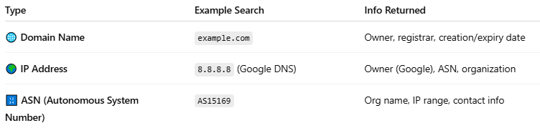

Type | Example Search | Info Returned
🌐 Domain Name | example.com | Owner, registrar, creation/expiry date
🌍 IP Address | 8.8.8.8 (Google DNS) | Owner (Google), ASN, organization
🔢 ASN (Autonomous System Number) | AS15169 | Org name, IP range, contact info

📜 Sample WHOIS Domain Result
# Source: Chatgpt (GPT‑5 Mini) at [12/15/2025]
For example.com:
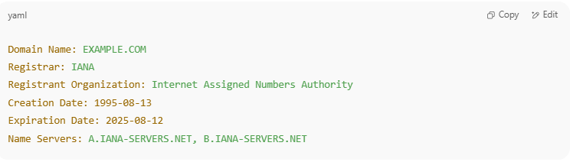
Domain Name: EXAMPLE.COM
Registrar: IANA
Registrant Organization: Internet Assigned Numbers Authority
Creation Date: 1995-08-13
Expiration Date: 2025-08-12
Name Servers: A.IANA-SERVERS.NET, B.IANA-SERVERS.NET

🧾 Sample WHOIS IP Result (via ARIN)
# Source: Chatgpt (GPT‑5 Mini) at [12/15/2025]
For IP 8.8.8.8:
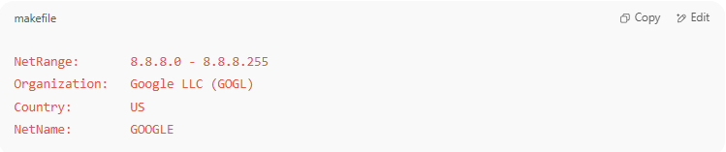
NetRange: 8.8.8.0 - 8.8.8.255
Organization: Google LLC (GOGL)
Country: US
NetName: GOOGLE

🛠️ WHOIS Lookup Tools
# Source: Chatgpt (GPT‑5 Mini) at [12/15/2025]
You can use:
- https://whois.domaintools.com
- https://whois.arin.net
- whois command in Linux/macOS terminal:
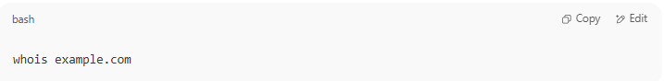
whois example.com

🔐 Can WHOIS Be Private?
# Source: Chatgpt (GPT‑5 Mini) at [12/15/2025]
Yes. Many domain registrars offer WHOIS privacy protection, which hides the registrant’s name and contact info to protect against spam or harassment.

✅ Summary
# Source: Chatgpt (GPT‑5 Mini) at [12/15/2025]
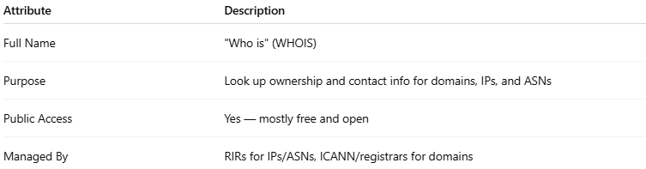

Attribute | Description
Full Name | "Who is" (WHOIS)
Purpose | Look up ownership and contact info for domains, IPs, and ASNs
Public Access | Yes — mostly free and open
Managed By | RIRs for IPs/ASNs, ICANN/registrars for domains

